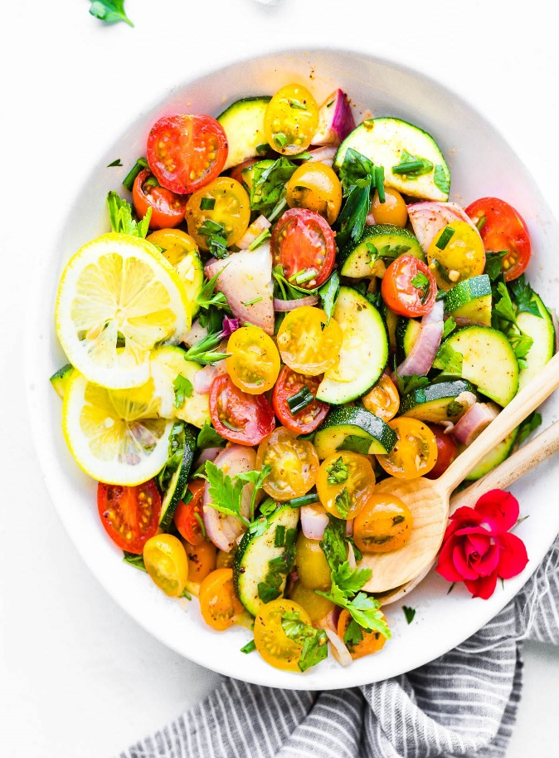
Zucchini Salad
RECIPE
INGREDIENTS
- 6 pints cherry tomatoes, halved
- 6 zucchini, halved and sliced
- 2/3 cup red onion, chopped
- Dried chives, parsley, basil
- 1 – 1 ¼ cups olive oil
- 2 tablespoon fresh garlic, chopped
- Salt and pepper
- 6 tablespoon lemon juice
- Optional Ingredients
6 diced tomatoes, smoked paprika

DIRECTIONS
- Place tomato, onion and zucchini in a large serving bowl.
- Season vegetables with chives, parsley and basil to taste.
- Combine olive oil, garlic, salt, pepper, and lemon to juice together in a bowl. Whisk together. Pour over vegetables.
- Garnish with extra lemon slices and salt/pepper to taste.
- Serve right away or store in air tight container for up to 3-4 days.

Prep Time: 30 minutes | Cook Time: 0 minutes | Total Time: 30 minutes | Yield: 24 servings

