Zucchini Bread
RECIPE
INGREDIENTS
- 3 cups flour
- 1 teaspoon salt
- 1 teaspoon baking soda
- 1 teaspoon baking powder
- 1 tablespoon cinnamon
- 3 eggs
- 1 cup oil
- 2 ¼ cups sugar
- 1 tablespoon vanilla extract
- 2 cups zucchini, grated
- 1 cup walnuts, chopped
- Optional Ingredients:
pecans

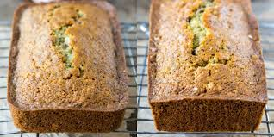

DIRECTIONS
- Preheat oven to 325 degrees. Spray two loaf pans with non-stick spray.
- Sift flour, salt, baking powder, soda, and cinnamon together in a bowl.
- Beat eggs, oil, vanilla, and sugar together in a large bowl. Add sifted ingredients to the creamed mixture, and beat well. Stir in zucchini and nuts until well combined. Pour batter into prepared pans.
- Bake for 40 to 60 minutes, or until tester inserted in the center comes out clean. Cool in pan on rack for 20 minutes. Remove bread from pan, and completely cool.

Prep Time: 20 minutes | Cook Time: 40-60 minutes | Total Time: 60-80 minutes | Yield: 2 loaves

