White Bean Salad
RECIPE
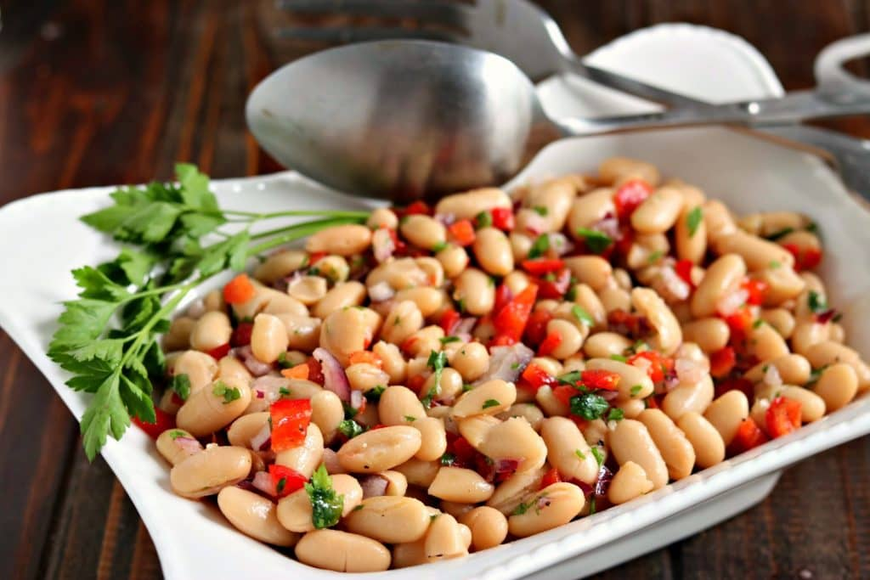
INGREDIENTS
- 1 (#10) can of white beans, drained and rinsed
- 1 ½ cups red bell pepper, finely chopped
- 1 ½ cups red onion, finely chopped
- Dried parsley

DRESSING
- ¾ cup olive oil
- ¾ cup white wine vinegar
- 2 tablespoons garlic, minced
- Salt and pepper

DIRECTIONS
- Place the beans, red pepper, onion and parsley in a large salad bowl.
- In a lidded jar, add the olive oil, vinegar, garlic, salt & pepper. Put the lid on tightly, and shake until well combined.
- Add the dressing to the bean mixture, using a spatula to combine (gently – so you don’t break the beans).
- Taste, add more seasoning if needed.
- Refrigerate until needed

Prep Time: 20 minutes | Cook Time: 0 minutes | Total Time: 20 minutes | Yield: 24 servings

