Ultimate Garlic Pork Loin Roast
RECIPE
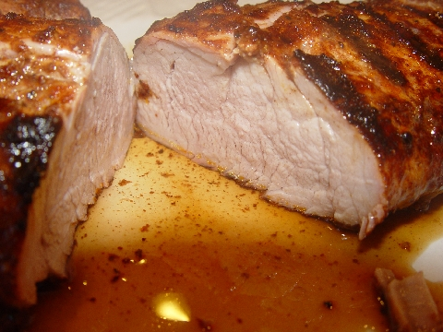
INGREDIENTS
- 5 pound pork loin
- 6 cloves garlic, minced
- ½ tsp salt
- ½ tsp ground black pepper
- ¼ tsp paprika

DIRECTIONS
- Preheat oven to 350 degrees
- Place backing rack in pan and place pork loin on rack.
- Coat top of loin with minced garlic.
- Mix the seasonings in small bowl and rub it on the pork loin.
- Cook the pork uncovered for 50-60 minutes or until it has reached a temperature of 145 degrees.
- Remove from oven and let sit for ten minutes. The resting will seal in the juices and the internal temperature will rise 10 to 15 degrees more, giving you the perfectly cooked pork loin and a great roast to carve for your guests.

Prep Time: 10 minutes | Cook Time: 60 minutes | Total Time: 70 minutes | Yield: 20 servings

