Tomato Salads
RECIPE
DIRECTIONS
- Dice tomatoes into large pieces.
- Peal cucumbers, cut in half and then slice. (some/all peel may be left on the cucumbers if washed thoroughly)
- Slice red onion.
- Combine first three ingredients and then pour over the desire amount of Italian dressing.
INGREDIENTS
- 10 cups tomatoes
- 10 cups cucumbers
- 2 red onions
- Italian Dressing
- Optional Ingredients:
Basil, parsley, parmesan cheese, garlic croutons

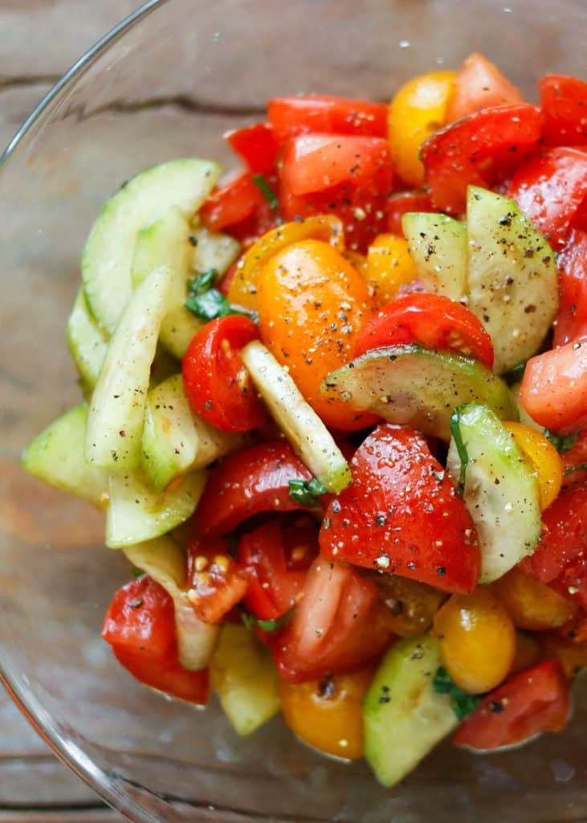

DIRECTIONS
- Arrange tomatoes and onions on a large serving platter. In a small bowl, whisk the oil, lemon juice, oregano, salt and pepper. Drizzle over top. Sprinkle with parsley.
INGREDIENTS
- 16 tomatoes
- 3-4 sweet onions, large
- 2/3 cup olive oil
- 4 tablespoons lemon juice
- 2 teaspoon dried oregano
- Salt and pepper
- Parsley

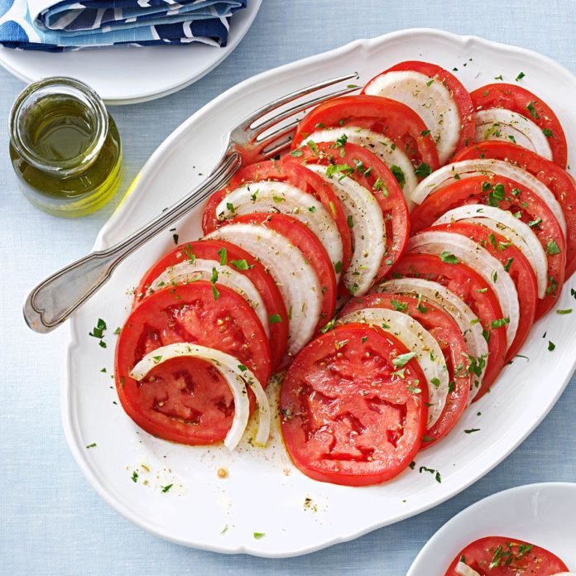

Prep Time: 20 minutes | Cook Time: 0 minutes | Total Time: 20 minutes | Yield: 20-24 servings

