Three Bean Salad
RECIPE
INGREDIENTS
- 1 (#10) can green beans, drained
- 1 (#10) can wax bean, drained
- ½ (#10) can kidney beans, rinsed and drained
- 1 large sweet onion, chopped

DRESSING INGREDIENTS
- ¾ cup sugar
- 1 ¾ cup apple cider vinegar
- 1 ¾ cup olive oil
- Salt and pepper

OPTIONAL INGREDIENTS
- Garbanzo beans, great northern beans, lima beans, pinto beans, corn, red onion, bell pepper, celery, parsley, rosemary, Italian dressing

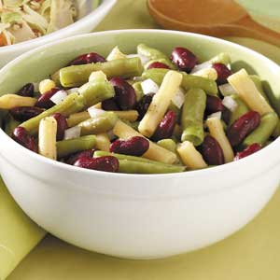

DIRECTIONS
- Combine three types of beans and onion together in a large bowl.
- In a small bowl, whisk sugar, vinegar, oil, salt and pepper. Stir into bean mixture.
- Cover and refrigerate until serving.

Prep Time: 30 minutes | Cook Time: 40 minutes | Total Time: 70 minutes | Yield: 42 servings

