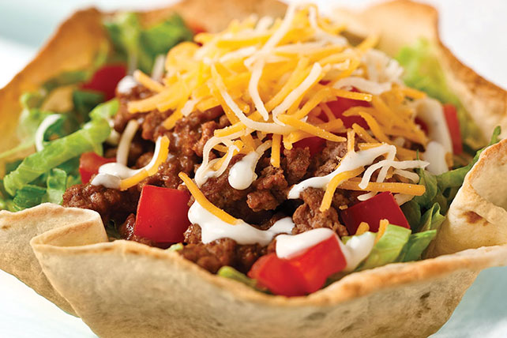
Taco Salad
RECIPE
INGREDIENTS
- 5 pounds ground beef
- 5 tablespoons chili powder
- 5 teaspoons cumin
- 2 ½ teaspoons garlic powder
- 2 ½ teaspoons onion powder
- 2 ½ teaspoons paprika
- 1 ¼ teaspoon oregano
- 2 ½ tablespoons oil
- 2 cups water
- 20 flour tortilla shells (8-inch size)
- Optional Ingredients:
Tortilla chips

For Toppings
- 5 heads lettuce
- 5 cups tomatoes
- 1 2/3 cups chopped green or red onions
- 5 cups shredded cheese
- Optional Ingredients
pinto beans, kidney beans, salsa, sour cream
guacamole, avocado

DIRECTIONS
- Heat oven to 425 degrees.
- To form tortilla bowls: Crumple up aluminum foil to make 3- inch balls. Place 1 tortilla over each ball and spray with non-stick spray. Bake 6-8 minutes or until tortillas are golden brown (Tortillas will drape over foil balls to form shells as they bake).
- In a large bowl, add lettuce tomatoes, onion and shredded cheese. Toss to combine and set aside. (May also serve each toppings separately in smaller bowls under sneeze guard so customers can place preferred toppings on their meat).
- In a large bowl, add ground beef, chili powder, cumin, garlic powder, onion powder, paprika and oregano. Mix together until well combined.
- Heat a large pan over medium-high heat. When hot, add oil. Add ground beef mixture breaking up meat into smaller chunks. Cook stirring occasionally until beef is completely browned.
- Add water and bring to a simmer. Simmer for 10 minutes.

Prep Time: 30 minutes | Cook Time: 20 minutes | Total Time: 50 minutes | Yield: 20 servings

