Swiss Steak
RECIPE
INGREDIENTS
- 20 cube steak
- 2 cups flour
- 2 tablespoons seasoning salt
- 1 cup oil divided
- 1-2 cups chopped celery
- 2-3 large green peppers julienne sliced
- 2-3 cups white onion sliced
- 1 #10 can stewed tomatoes
- 1 cup water

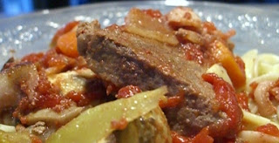

- Pre-heat oven to 350 degrees
- Add flour and seasoning salt in pan and then dredge cube steaks in flour mixture and then brown in two large skillets.
- When browned, place steaks in 2-inch-deep full cafeteria pans and pour vegetables over meat. Cover with foil and bake at 350 degrees for 1 hour.

Prep Time: 30 minutes | Cook Time: 60 minutes | Total Time: 90 minutes | Yield: 20 servings

