Sweet Potatoes (Glazed and Baked)
RECIPE
DIRECTIONS
- Preheat oven to 350°. Spray 2” pan with non-stick spray.
- Place sweet potatoes in prepared pan.
- In a small saucepan, combine butter, syrup, brown sugar and cinnamon; bring to a boil, stirring constantly. Pour over potatoes.
- Bake, uncovered, 30-40 minutes or until heated through.
INGREDIENTS
- 2 cans (#10) sweet potatoes, drained
- 1 ½ cups butter
- 1 ½ cups maple syrup
- 1 ½ cups packed brown sugar
- 1 ½ teaspoons ground cinnamon
- Salt and pepper

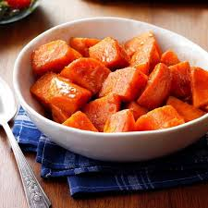

DIRECTIONS
- Preheat oven to 375°F.
- Wash and dry the potatoes. Poke about 3-4 times on each side.
- Rub the skin with olive oil and sprinkle with salt and pepper.
- Bake 50-60 minutes or until tender when pierced with a fork. Allow to cool 5 minutes before cutting open.
INGREDIENTS
- sweet potatoes
- olive oil
- salt & pepper

Prep Time: 20 minutes | Cook Time: 40-60 minutes | Total Time: 60-80 minutes | Yield: 14 servings

