Sweet Potato Salad
RECIPE
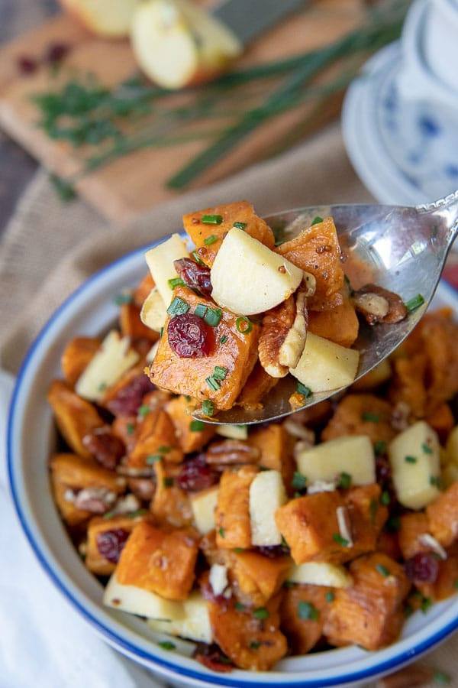
4
INGREDIENTS
- 8 pounds sweet potatoes, peeled and cubed 1” chunks
- ½ cup olive oil
- Salt and pepper
- 3 medium apples, chopped
- 1 ½ cup pecans, chopped
- 1 cup dried cranberries

DRESSING INGREDIENTS
- 3 tablespoons olive oil
- 2 tablespoons apple cider vinegar
- 3 tablespoons maple syrup
- 3 tablespoons stone ground mustard
- 3 tablespoons Dijon mustard
- 2 teaspoons dried chives

DIRECTIONS
- Preheat oven to 375°F. Spray two sheet pans with nonstick spray. Divide sweet potatoes between baking sheets. Divide olive oil, salt, and pepper between the two sheets. Toss to combine.
- Spread sweet potatoes in a single layer so they aren't touching. Bake for 25 minutes. Toss and flip sweet potatoes, then bake for 15 minutes more. They should have a crispy, caramelized exterior and soft interior.
- Meanwhile whisk together dressing ingredients in a small bowl.
- In a large bowl place cooled sweet potatoes, apples, pecans, and dried cranberries. Gently toss with dressing. Serve warm, room temperature, or cold.

Optional Ingredients
- Bacon, kale, quinoa, parmesan cheese, feta cheese, walnuts, cashews, red onions, green onions, bell peppers, lemon juice, red pepper flakes, cayenne

Prep Time: 30 minutes | Cook Time: 40 minutes | Total Time: 70 minutes | Yield: 24 servings

