Sweet-n-Sour Chicken
RECIPE
INGREDIENTS
- 5 pounds frozen fully cooked breaded chicken breast chunks
- Optional Ingredients:
sesame seeds

For Sauce
- 3 cups pineapple tidbits
- 3 red bell peppers cut into 1” chunks
- 3 green bell peppers cut into 1” chunks
- 1 ½ yellow onions cut into 1” chunks
- 1 ½ cups sugar
- ¾ cup brown sugar
- 1 ½ cups apple cider vinegar
- 1 cup ketchup
- 4 tablespoons low sodium soy sauce
- 6 cloves garlic minced
- Optional Ingredients:
cornstarch and water to thicken
(may use Minors sauce instead)

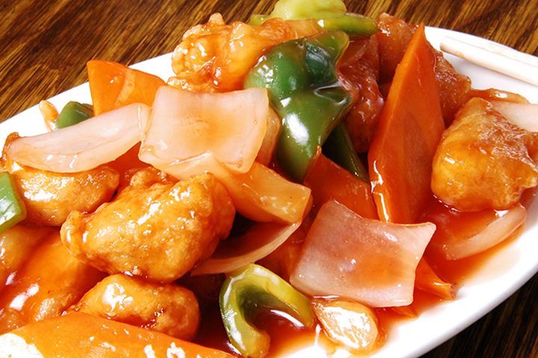

DIRECTIONS
- Preheat oven to 375degrees. Place chicken chunks on tray and bake as directed on package.
- For sauce: whisk together the sugar, brown sugar, apple cider vinegar, ketchup, soy sauce and garlic in a pot. Add bell peppers, onion and pineapple. Bring to a low boil and cook for 3 minutes so that peppers and onions are crisp-tender. You may add a cornstarch and water slurry if needed to thicken. Do not add chicken to sauce. Pour sauce over chicken when served.

Prep Time: 20 minutes | Cook Time: 30 minutes | Total Time: 50 minutes | Yield: 20 servings

