Sweet Mustard Baked Pork Chops
RECIPE
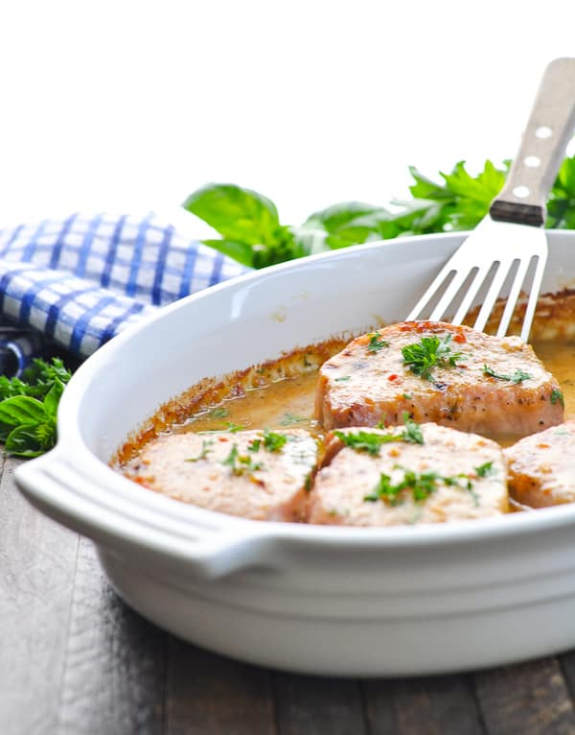
INGREDIENTS
- 24 pork chops
- 5 cup Italian salad dressing
- 2 ½ cup brown sugar
- 2 ½ cup Dijon mustard
- Salt and pepper to taste
- Optional Ingredients:
parsley

DIRECTIONS
- Preheat oven to 375 degrees F. Spray a 2” pan with non-stick spray and set aside.
- Pat pork chops dry with a paper towel, and season on both sides with salt and pepper.
- Place pork chops in prepared pan.
- In a large measuring cup or bowl, whisk together salad dressing, brown sugar, and Dijon mustard. Pour over pork chops.
- Bake uncovered until pork reaching an internal temperature of at least 145 degrees – about 40-50 minutes.
- Loosely cover pork with foil and allow to rest for at least 5-10 minutes.
- Garnish with fresh parsley just before serving.

Prep Time: 5 minutes | Cook Time: 40-50 minutes | Total Time: 45-55 minutes | Yield: 24 servings

