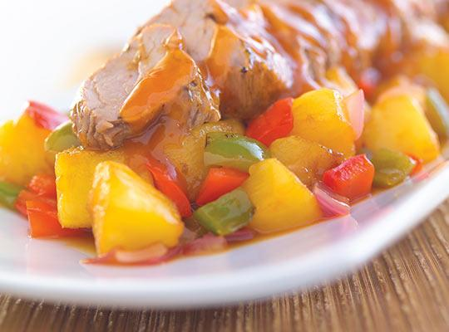
Sweet-n-Sour Pork Loin
RECIPE
INGREDIENTS
- 5 pound pork loin
- ¼ cup vegetable oil
- 3 tbsp. pork or chicken base
- 1 tbsp. black pepper
- 4 tbsp. vegetable oil

For Sauce
- 3 cups pineapple tidbits
- 3 red bell peppers cut into 1” chunks
- 3 green bell peppers cut into 1” chunks
- 1 ½ yellow onions cut into 1” chunks
- 1 ½ cups sugar
- ¾ cup brown sugar
- 1 ½ cups apple cider vinegar
- 1 cup ketchup
- 4 tablespoons low sodium soy sauce
- 6 cloves garlic minced
- Optional Ingredients:
cornstarch and water to thicken
(may use Minors sauce instead)

DIRECTIONS
- Preheat oven to 350 degrees.
- In a small bowl, mix together oil, meat base, and pepper until well blended. Rub paste into all sides of pork loin to coat well.
- In a large skillet over medium heat, sear all of the loin until brown (loin may be cut to fit pan). Place loin on foil lined sheet pan and roast in a preheated oven till internal temperature reaches 145 degrees. Remove from oven and let rest for 10 minutes.
- For sauce: whisk together the sugar, brown sugar, apple cider vinegar, ketchup, soy sauce and garlic in a pot. Add bell peppers, onion and pineapple. Bring to a low boil and cook for 3 minutes so that peppers and onions are crisp-tender. You may add a cornstarch and water slurry if needed to thicken.
- Cut pork into 1 inch slices and place in full size 2” pan. Pour sauce over pork when served.

Prep Time: 30 minutes | Cook Time: 40 minutes | Total Time: 70 minutes | Yield: 24 servings

