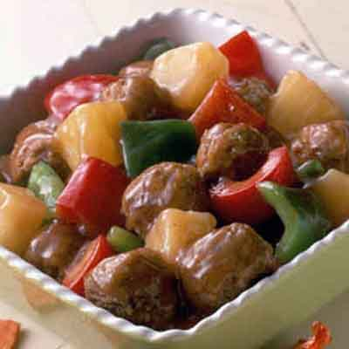
Sweet-n-Sour Meatballs
INGREDIENTS
- 5 pounds ground beef
- 5 eggs
- 1 ¼ cup bread crumbs
- ¾ cup milk
- 2 ½ teaspoons garlic powder
- 1 ¼ cup diced onion
- Salt and pepper
- Optional Ingredients:
garlic minced, cracker crumbs, ginger
pre-cooked Italian meatballs

For Sauce
- 3 cups pineapple chunks
- 6 red and green bell peppers cut into 1” chunks
- 1 ½ yellow onions cut into 1” chunks
- 1 ½ cups sugar
- ¾ cup brown sugar
- 1 ½ cups apple cider vinegar
- 1 cup ketchup
- 4 tablespoons low sodium soy sauce
- 6 cloves garlic minced
- Optional Ingredients:
Cornstarch/water slurry to thicken, Minors sweet & sour sauce

RECIPE

DIRECTIONS
- Preheat oven to 375 degrees. Prepare pans with parchment paper.
- In a large bowl, mix together all ingredients for the meatballs.
- Using a 1-ounce scoop, form meatballs. Place meatballs on prepared pan.
- Bake for 20 minutes or until internal temperature is 165 degrees.
- For sauce: whisk together the sugar, brown sugar, apple cider vinegar, ketchup, soy sauce and garlic in a pot. Add bell peppers, onion and pineapple. Bring to a low boil and cook for 3 minutes so that peppers and onions are crisp-tender. You may add a cornstarch and water slurry if needed to thicken. Do not add meatballs to sauce. Pour sauce over meatballs when served.

Prep Time: 30 minutes | Cook Time: 30 minutes | Total Time: 60 minutes | Yield: 20-26 servings

