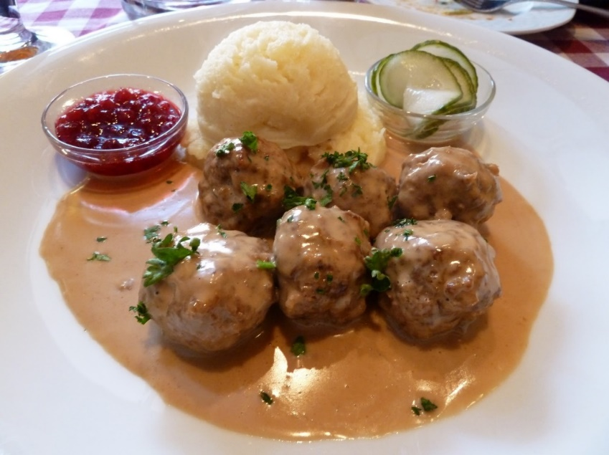
Swedish Meatballs
RECIPE

INGREDIENTS
- 5 pounds ground beef
- 5 eggs
- 1 ¼ cup bread crumbs
- 2 tablespoons dried parsley
- 1 ¼ teaspoon allspice
- 1 ¼ teaspoon ground nutmeg
- 2 ½ teaspoons garlic powder
- 1 ¼ cup diced onion
- Salt and pepper
- Optional Ingredients:
garlic minced, cracker crumbs
pre-cooked Italian meatballs

For Sauce
- 2/3 cup butter
- 1 cup flour
- 6 cups beef broth
- 3 cups milk or heavy cream
- 2/3 cup Worcestershire sauce
- 2 teaspoons dried or fresh parsley
- Salt and pepper

DIRECTIONS
- Preheat oven to 375 degrees. Prepare pan with parchment paper.
- In a large bowl, mix together all ingredients for the meatballs.
- Using a 1-ounce scoop, form meatballs. Place meatballs on prepared pan.
- Bake for 20 minutes or until internal temperature is 165 degrees.
- Heat pan to medium-low heat. Melt butter and whisk in flour until it has turned golden brown
- Slowly whisk in beef broth and cook until thickened,
- Add in milk or cream, Worcestershire sauce, parsley, pepper, and salt. Continue to stir until well-combined.
- Add meatballs back into the skillet, turning to coat well.
- To serve, place 4-5 meatballs with sauce on plate over rice or potatoes.

Prep Time: 30 minutes | Cook Time: 30 minutes | Total Time: 65 minutes | Yield: 20 servings

