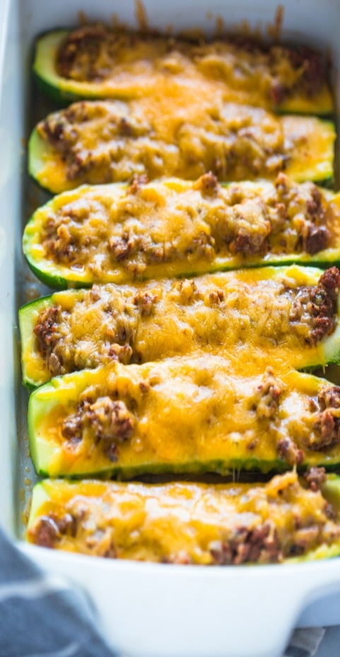
Stuffed Squash
RECIPE
INGREDIENTS
- 12 medium zucchini
- 5 pounds ground beef
- 4 tablespoons olive oil
- 2 cups onion, chopped
- 8 cloves garlic, minced
- 4 cups pasta sauce
- 4 tablespoons Italian seasoning
- Salt and pepper
- 4 cups cheddar or mozzarella cheese
- Optional Ingredients:
yellow, squash, ground sausage/turkey or chicken, vegetable oil, mushrooms, red or green bell pepper, crushed red pepper, ketchup, parsley, parmesan cheese, bread crumb garnish

Note: Fresh zucchini or other squash types are not on the order guide and should only be obtained through OFH or as a donation.

DIRECTIONS
- Preheat oven to 350 degrees. Fan speed low. Spray 2” pan with non-stick spray.
- Trim ends from zucchini and slice in half. Scrape out zucchini flesh, finely chop it and set aside. Place zucchini in prepared pan.
- Heat olive oil on stove and cook onions for 2-3 minutes, add garlic and cook for 1 minute. Add ground beef stirring to break up clumps until meat cooks. Drain excess fat.
- Add zucchini flesh, pasta sauce, Italian seasoning, salt, pepper and any other optional ingredients you desire. Allow to simmer for 8-10 minutes.
- Stuff zucchini with meat mixture. Cover with foil and bake for 25-30 minutes or until zucchini is tender.
- Remove foil and sprinkle cheddar or mozzarella cheese on top. Place back in oven until cheese is melted.

Prep Time: 30 minutes | Cook Time: 60 minutes | Total Time: 90 minutes | Yield: 24 servings

