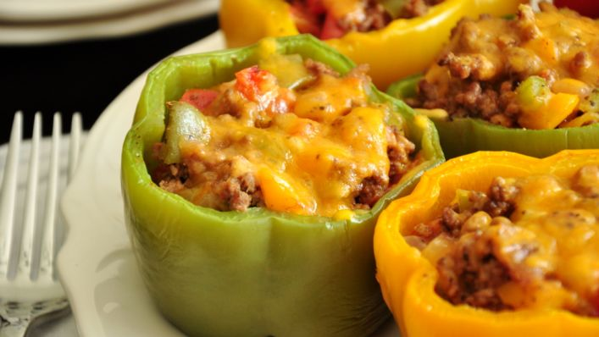
Stuffed Peppers
RECIPE

INGREDIENTS
- 20 green, red or yellow peppers
- 3 pounds ground beef
- 1 ½ cups onion, chopped
- 3 cups diced canned tomatoes, drained
- ¾ cup long grain white or brown rice
- 3 cups water
- Salt & pepper to taste
- 3 teaspoons Worcestershire sauce
- 3 cups cheddar cheese
- Optional Ingredients:
mozzarella for cheddar, tomato sauce, garlic powder, Italian seasoning, pasta sauce

DIRECTIONS
- Preheat oven to 350 degrees.
- Cut off the tops of green peppers; discard seeds and membranes. Chop enough of the tops to make 1/4 cup, set aside.
- Cook peppers, uncovered in boiling water for about 5 minutes; invert to drain well. Sprinkle insides of the peppers lightly with salt.
- In a pan, cook ground beef, onion and 1/4 cup chopped pepper till meat is browned and vegetables are tender. Drain off excess fat. Add drained tomatoes, Worcestershire sauce, and a dash of pepper.
- In a separate pot, bring water to a boil add rice. Cook until rice is soft. If needed add more water. Add cooked rice to beef mixture.
- Stir in 2 ½ cups cheese. Stuff peppers with meat mixture.
- Place peppers in pan and bake covered oven for 25 minutes.
- Add remaining cheese to the top of the peppers and bake for an additional 5 minutes or until internal temperature reaches 165 degrees.

Prep Time: 25 minutes | Cook Time: 30 minutes | Total Time: 55 minutes | Yield: 20 servings

