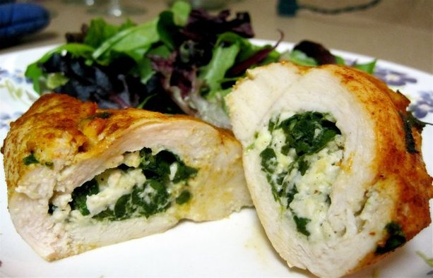
Stuffed Chicken Breasts
RECIPE
INGREDIENTS
- 20 chicken breasts
- 1/3 cup oil
- Salt and pepper
- Paprika

For Stuffing
- shredded mozzarella cheese
- spinach
- 2 tablespoon garlic powder
- Optional Ingredients:
provolone cheese, swiss cheese, cream cheese, onion, minced garlic

Note: Have fun with the stuffing! Other possibilities might include: apple & raisin bread stuffing, asparagus and cheese, broccoli and rice.

DIRECTIONS
- Preheat oven to 400 degrees. Line a large baking sheet with parchment paper and set aside.
- Drain spinach and mix in garlic powder. Set aside.
- Pat the chicken dry with paper towels. Pound chicken to flatten.
- Place cheese on chicken and place a heaping tablespoon of spinach/garlic mixture on cheese. Roll over chicken breast and secure with a toothpick. Place on the baking sheet.
- Drizzle oil evenly over chicken, rubbing to coat well.
- Season with salt and pepper. Sprinkle paprika over chicken.
- Bake in preheated oven uncovered for 30 minutes. Reduce heat to 375F and bake for 10-20 minutes or until internal temperature reaches 165 degrees.
- Remove toothpick before serving.

Prep Time: 20 minutes | Cook Time: 35-45 minutes | Total Time: 55-65 minutes | Yield: 20 servings

