Spinach Salad
RECIPE

INGREDIENTS
- 10-12 cups fresh spinach
- 5 apples, diced or sliced
- 1 ¼ cup red onion, sliced
- 1 ¼ cup sliced almonds, toasted
- Optional Ingredients:
Strawberries, mandarin oranges, etc… bacon

For Dressing
- 1 2/3 cup olive oil
- 1 cup red wine vinegar
- 5 cloves garlic, minced
- 3 tablespoons Dijon mustard
- Salt and pepper

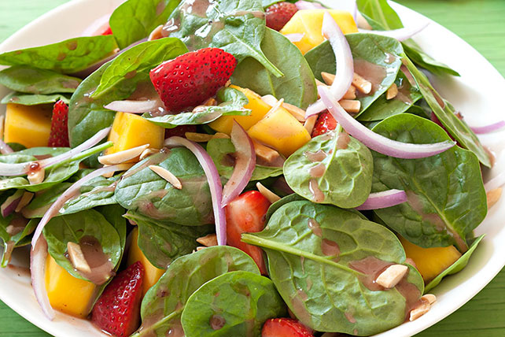

DIRECTIONS
- In a medium bowl, whisk together all dressing ingredients until completely incorporated. Season with salt and pepper.
- Combine all salad ingredients in a large bowl. Add dressing, toss to combine, and serve immediately.

Prep Time: 15 minutes | Cook Time: 0 minutes | Total Time: 15 minutes | Yield: 20 servings

