Spiced Peaches or Pears
RECIPE
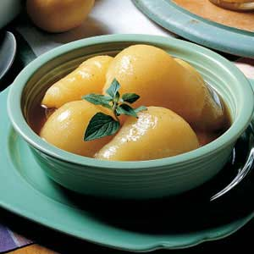
INGREDIENTS
- 1 (#10) can peaches or pears
- 2 cups packed brown sugar
- 4 ½ teaspoons ground nutmeg
- 4 ½ teaspoons ground cinnamon
- Optional Ingredients:
Ground cloves, vanilla extract

DIRECTIONS
- Drain peaches or pears, reserving syrup; set the pears aside.
- In a small saucepan, combine the syrup, brown sugar, nutmeg and cinnamon. Bring to a boil.
- Reduce heat; simmer, uncovered, for 5 minutes, stirring frequently. Add peaches or pears and simmer for about 5 minutes more or until heated through.
- Cool and serve.

Prep Time: 5 minutes | Cook Time: 10 minutes | Total Time: 15 minutes | Yield: 20-24 servings

