Spanish Rice
RECIPE
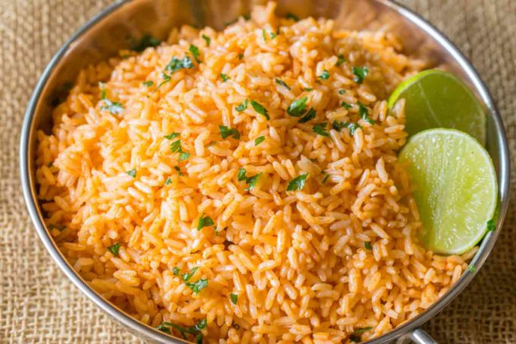
INGREDIENTS
- 6 tablespoons oil
- 3 ¾ cups uncooked white rice
- 4 ½ cups chicken stock
- ½ can (#10) tomato sauce
- 3 teaspoons chili powder
- 1 ½ teaspoons cumin
- 3 teaspoon garlic salt
- Optional Ingredients
Cilantro, chopped onion, diced tomatoes, paprika, minced garlic

DIRECTIONS
- Add the oil and rice in a large pot on medium high heat, stirring until translucent (less white, more see-through-ish), about 3-4 minutes.
- Add in the broth, tomato sauce, chili powder, cumin and garlic salt. Bring to a boil, then lower the heat to simmer.
- Cover, cooking 20 minutes then letting rest an additional five minutes before fluffing.

Prep Time: 10 minutes | Cook Time: 25 minutes | Total Time: 35 minutes | Yield: 24 servings

