Salisbury Steak
Note: No need for an additional carbohydrate since the main dish contains pasta
RECIPE
INGREDIENTS
- 5 pounds ground beef
- Salt and pepper
- 5 onions, chopped small
- 2 ½ teaspoons garlic powder
- 1-2 #10 cans pasta sauce
- Optional Ingredients:
minced garlic, diced bell pepper, diced tomatoes, oregano, thyme, parsley, basil, paprika, sugar, penne pasta

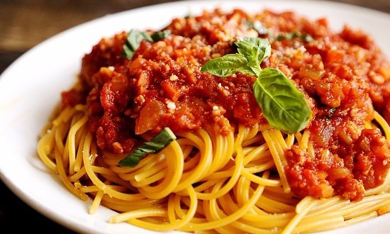

DIRECTIONS
- Combine ground beef, salt, pepper, onion and garlic powder in a large saucepan. Cook and stir until meat is brown. Drain grease.
- Add pasta sauce. Simmer until meat and sauce reach 165 degrees.
- Serve over preferred pasta topped with Parmesan cheese.

Prep Time: 10 minutes | Cook Time: 20 minutes | Total Time: 30 minutes | Yield: 20-25 servings

