Southern Smothered Chicken
RECIPE
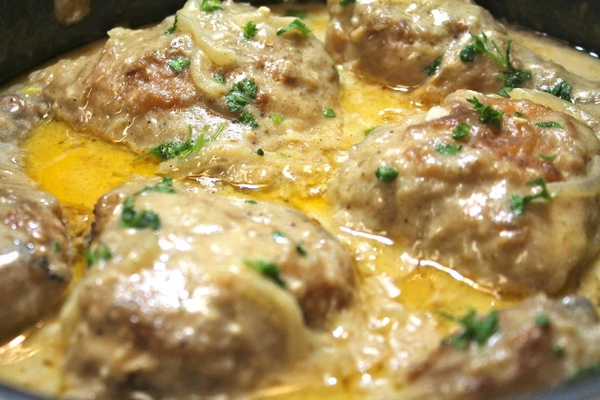
DIRECTIONS
- Preheat oven to 35 degrees. Spray a baking pan with non-stick spray.
- Mix flour and seasonings in a bowl. Coat chicken with seasoned flour. Reserve the seasoned flour.
- Pour ¼ cup vegetable oil into a large pan over medium heat. Add chicken, (do not over crowd pan). May need to cook chicken in batches adding oil when needed. Cook chicken until it is golden brown. (Don’t worry about cooking the chicken until done, because we will cook it some more). Remove chicken and place in prepared baking pan.
- Toss onions in pan with oil used to cook chicken. Sauté for about 2 minutes, then add in garlic. Sauté for one minute longer. Add approx. 1/3 cup of the seasoned flour (the same flour that you coat the chicken with) to the pan. Stir in with the oil to make a rue.
- Next pour in chicken broth (use chicken base and water as directed to make broth). Whisk in while pouring in the broth. Make sure there aren't any lumps. Let the gravy cook for about 2 minutes (medium heat), then pour in milk and continue stirring. Let gravy cook for about 3 minutes.
- Pour gravy mixture over chicken making sure all of the chicken is coated. Bake for 20-30 minutes. Internal chicken temperature should be 165 degrees.

INGREDIENTS
- 24 chicken pieces
- 4 ½ -6 cups flour
- Salt and pepper
- 4 tablespoon onion powder
- 4 teaspoons poultry seasoning
- 4 tablespoons garlic powder
- 4 teaspoons paprika
- 1 cup oil
- 8 cups low sodium chicken stock
- 4 cup whole milk
- 3 tablespoons minced garlic
- 4 medium onions, cut in half & sliced
- Optional Ingredients:
Steak seasoning, parsley, celery seed, heavy cream, seasoned salt

Prep Time: 10 minutes | Cook Time: 40-50 minutes | Total Time: 50-60 minutes | Yield: 24 servings

