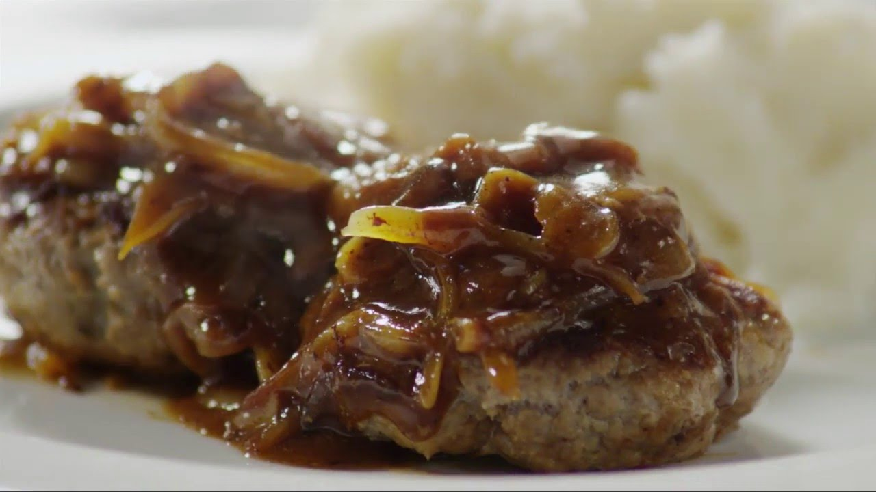
Smothered Steak and Onions
RECIPE
INGREDIENTS
- 5 pounds ground beef
- 5 eggs
- 1 ¼ cups dry breadcrumbs
- ½ teaspoon black pepper
- 2 teaspoons seasoned salt
- 2 ½ teaspoons garlic powder
- 2 ½ tablespoons onion powder
- 2 tablespoons Worcestershire sauce
- 5 cups onions sliced
- Optional Ingredients:
onion minced

For Gravy
- 1 package of Roasted Brown Gravy Mix
- 1 gallon of water

DIRECTIONS
- Bring water to a boil on stove top. Add gravy mix stirring continuously until gravy is thick. Set aside.
- Preheat oven to 375 degrees. Spray a 2” pan with non-stick spray.
- Place the ground beef into a large bowl and add eggs, bread crumbs, pepper, salt, onion powder, garlic powder and Worcestershire sauce. Mix to combine.
- Using a 4-ounce scoop, make 20 meat balls and shape them into oval patties flattening slightly.
- Fry patties in skillet browning meat on both sides. Meat will not be completely cooked. Transfer beef patties to a 2” pan and place onion slices on top of meat and cover with prepared gravy.
- Bake in oven for 30-40 minutes or until internal meat temperature reaches 165 degrees.

Prep Time: 10 minutes | Cook Time: 40 minutes | Total Time: 50 minutes | Yield: 20 servings

