Smothered Pork Chops and Potatoes
RECIPE
INGREDIENTS
- 24 pork chops
- 20 medium potatoes, peeled and sliced
- 5 medium onions, sliced
- 5 (10.5 oz.) cans cream of mushroom soup
- 1 ¼ cup heavy whipping cream
- 5 cup milk
- 2 tablespoons dried parsley
- Salt and pepper
- 7 cup shredded cheddar cheese
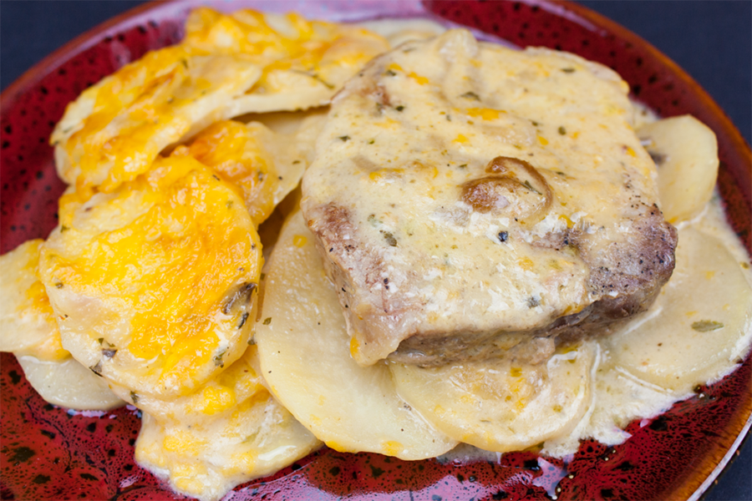

DIRECTIONS
- Preheat oven to 375F degrees.
- Heat a large skillet over medium-high heat, season the chops with salt and pepper. Brown both sides of the pork chops. Remove and set aside. Add onions to the skillet and sauté about 3 to 5 minutes.
- Whisk together the soup, milk, cream, dried parsley, salt, and pepper.
- Prepare 2” pan with non-stick spray. Spread half of the onions on the bottom, layer half of the potatoes over the onions, salt, and pepper to taste, sprinkle half of the cheese over the potatoes.
- Place chops on top and spoon about 2 tablespoons of sauce over each chop. Place remaining onions and potatoes over the pork chops. Pour remaining sauce evenly over the potatoes making sure some of the mixture seeps down through the cracks.
- Cover with foil and bake for 1 hour.
- Remove foil, sprinkle remaining cheese and bake 30 minutes. Allow to rest for 10 to 15 minutes and serve.

Prep Time: 25 minutes | Cook Time: 90 minutes | Total Time: 115 minutes | Yield: 24 servings

