Sloppy Joe
RECIPE
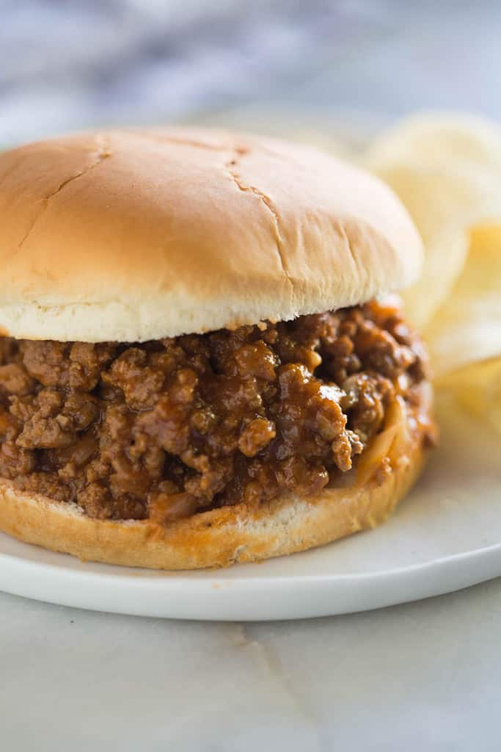
INGREDIENTS
- 5 pounds ground beef
- Salt and pepper
- 2 ½ cups diced onions
- 2 ½ teaspoons garlic powder
- 2 cups ketchup
- 2 (8oz) cans tomato sauce
- 1 ½ (6oz) cans tomato paste
- 1 tablespoon + 2 teaspoons of yellow mustard
- 10 tablespoons Worcestershire sauce
- 1/3 cup brown sugar
- 25 Hamburger buns
- Optional Ingredients:
garlic minced, bell peppers, paprika, vinegar

DIRECTIONS
- Add beef, onion and garlic to a large pan over medium heat.
- Season with salt and pepper.
- Cook, stirring, until browned so that ground beef crumbles. Drain grease.
- Add remaining ingredients to the pan.
- Simmer for 20 minutes, stirring occasionally.
- Serve warm on hamburger bun.

Prep Time: 10 minutes | Cook Time: 20 minutes | Total Time: 30 minutes | Yield: 25 servings

