Shrimp Boil
Note: Purchase shrimp from OFH when available
RECIPE
INGREDIENTS
- 10 lemons, halved
- 2 ½ cups Old Bay seasoning
- 40 cloves garlic, smashed
- 5 large onions, quartered
- 2 tablespoons dried thyme
- 5 pounds small red potatoes (halved or quartered)
- 20 ears of corn, halved
- 6 ¼ pounds shrimp, raw
- 10 tablespoons butter

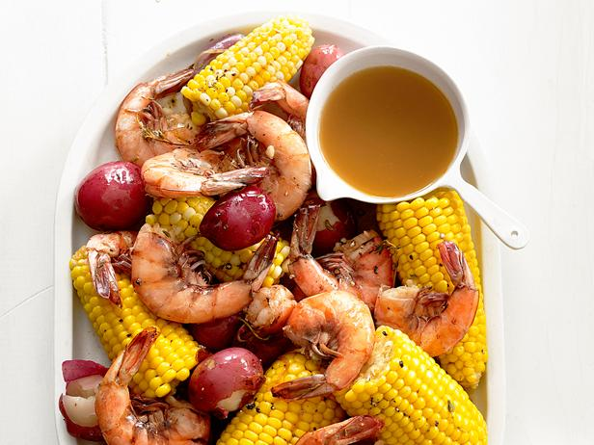

DIRECTIONS
- Fill a large pot with 20 quarts of water.
- Squeeze lemons above water and add the squeezed lemon halves to the pot. Add the Old Bay, garlic, onion and thyme to the pot. Cover and bring to a boil, then reduce to a simmer and cook about 5 minutes.
- Add the potatoes and cook until just tender, about 10 minutes.
- Add the corn and cook 5 more minutes.
- Meanwhile, slice along the back of each shrimp through the shells; remove the veins and rinse the shrimp. Add to the pot, cover and cook until the shrimp curl and are just opaque, 2 to 3 minutes.
- Transfer the shrimp and vegetables with a slotted spoon to steam pan. Add the butter and about 1 cup broth to the pan and toss until the butter is melted.

Prep Time: 20 minutes | Cook Time: 10-12 minutes | Total Time: 30-32minutes | Yield: 20 servings

