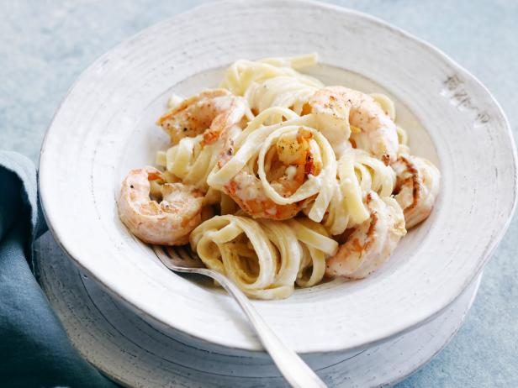
Shrimp Alfredo
Note: Purchase shrimp from OFH when available
RECIPE

DIRECTIONS
- For pasta: Bring a large pot of water to a boil, salt generously. Add the pasta, and boil according to package directions until al dente, tender but still slightly firm. Strain, and toss with a splash of oil.
- For shrimp: Pat shrimp with a paper towel until completely dry. Season with salt and pepper. Heat a large skillet over medium heat, add butter. When melted, raise the heat to medium-high, and add shrimp to skillet. Cook the shrimp, without moving them, until the underside is pink, 1 to 2 minutes. Flip the shrimp, and cook until fully pink and cooked through, about 2 minutes more. Transfer the shrimp to a steam pan to keep warm.
- For sauce: Melt butter in pot over medium heat and add garlic. Cook for 30 seconds, then reduce heat to medium-low. Season with salt and pepper. Whisk in flour, stirring until smooth. Slowly whisk in milk. Cook until sauce is slightly thickened and whisk in parmesan. Stir until smooth. Remove from heat and cover until ready to serve. If sauce is too thick, thin down with milk.
- Place pasta on plate, top with shrimp, then sauce. Garnish with parmesan and parsley if desired.

INGREDIENTS
- Salt for pasta water
- 5 lbs. pasta
- Olive oil for tossing
- 5 pounds of shrimp, raw and deveined, shells removed
- Salt and black pepper
- 10 tablespoons butter
- Optional Ingredients:
fresh parsley, broccoli florets
For Sauce
- 2 ½ cup butter
- 15 cloves garlic, minced
- Salt and pepper
- 7 ½ tablespoons flour
- 10 cups milk
- 3 ¾ cup grated Parmesan cheese
- Optional Ingredients:
nutmeg, mushrooms, heavy cream, Alfredo sauce mix

Prep Time: 15 minutes | Cook Time: 50 minutes | Total Time: 65 minutes | Yield: 20 servings

