Kielbasa and Pasta
Note: No need for an additional carbohydrate since the main dish contains pasta
RECIPE
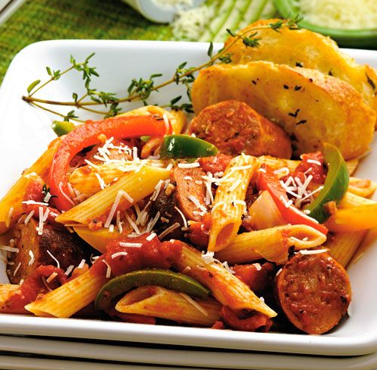
INGREDIENTS
- 2 pounds cooked pasta
- 4 pounds of Kielbasa sausage sliced diagonally into ¼ inch thick pieces
- 4 medium green bell peppers, julienned
- 60 ounces diced tomatoes undrained (75% of #10 can)
- 4 cups tomato sauce
- 2 tablespoons Italian seasoning
- 2 tablespoons garlic, chopped
- Salt and pepper
- Optional Ingredients:
cheese, onion, carrots, zucchini

DIRECTIONS
- Preheat oven to 350 degrees. Fan speed high. 2” pan with non-stick spray.
- Cook kielbasa in skillet over medium-high heat until browned. Remove and set aside.
- Add peppers to skillet and cook until tender, add garlic and Italian seasoning cooking for 1-2 minutes. Add diced tomatoes and tomato sauce cooking until heating through. Add salt and pepper to taste.
- Combine pasta, kielbasa and pepper mixture and place in prepared pan.
- Cover with foil and bake for 15-20 minutes. If adding cheese on top: Uncover, add cheese and bake until cheese is melted and browned slightly.

Prep Time: 25 minutes | Cook Time: 20 minutes | Total Time: 45minutes | Yield: 24 servings

