Sausage and Chicken Jambalaya
RECIPE
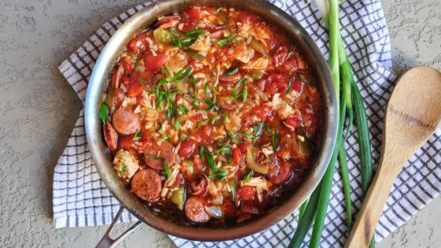
INGREDIENTS
- 3 tablespoon oil, divided
- 3 pounds kielbasa, sliced diagonally
- 4 mediums onion, chopped
- 4 green peppers, diced
- 12 celery ribs, chopped
- 12 garlic cloves, minced
- 3 pounds boneless skinless chicken, cubed
- 4 tablespoons Worcestershire sauce
- Salt and pepper
- 1½ - 2 teaspoons Cajun seasoning
- 6 bay leaves
- 1 teaspoon dried thyme
- 1 (310) can diced tomatoes with juice
- Optional Ingredients:
parsley, green onion, basil, sugar, red pepper flakes

DIRECTIONS
- Heat oil in skillet over medium-high heat; add sausage and cook until slightly browned (5 minutes). Remove and place in large pot.
- Add onions, bell peppers, celery and garlic and cook until softened (4 minutes).
- Add chicken cubes and Worcestershire sauce; cook until chicken is no longer pink. Place into pot with sausage.
- Add salt, pepper, Cajun seasoning, bay leaves, thyme and diced tomatoes to the meat and vegetable mixture. Bring to a boil, cover and reduce heat to low. Simmer for 20-30 minutes.
- Remove bay leaves. Serve over cooked rice or noodles.

Prep Time: 30minutes | Cook Time: 30-40 minutes | Total Time: 60-70 minutes | Yield: 24 servings

