Sausage Hashbrown Casserole
RECIPE
INGREDIENTS
- 6 pounds ground breakfast sausage
- 5 ½ pounds frozen hash browns
- 18 large eggs
- 6 cups whole milk
- Salt and pepper
- 3 cups cheddar cheese, shredded
- Optional Ingredients:
Paprika, bell peppers, mushrooms, mushroom soup, tomatoes, garlic powder, onion powder, onions, steak seasoning

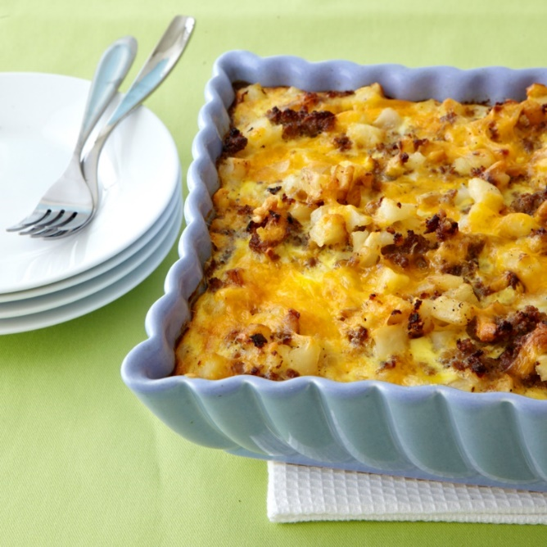

DIRECTIONS
- Preheat oven to 350 degrees. Spray a baking dish with non-stick spray.
- In a skillet, brown and crumble sausage; drain and set aside.
- Prepare hash browns according to package directions seasoning with salt and pepper.
- In a large bowl, stir together hash browns, sausage, cheese and any desired optional ingredients. Pour into prepared baking pan.
- Wisk together eggs, milk salt and pepper. Pour egg mixture over potato mixture.
- Bake, uncovered for 40-50 minutes or until a knife inserted in center comes out clean. (Serve with a vegetable or fruit)

Prep Time: 15 minutes | Cook Time: 40-50 minutes | Total Time: 55-65 minutes | Yield: 30 servings

