Sausage Egg Casserole
RECIPE
INGREDIENTS
- 3 pounds ground breakfast sausage
- 18 large eggs
- 6 cups whole milk
- 1 tablespoon ground mustard
- Salt and pepper
- 18 slices bread,cubed (any type)
- 3 cups cheddar cheese, shredded
- Optional Ingredients:
Paprika, cheddar jack cheese, yellow mustard,
dill, onions, bell peppers, mushrooms,
garlic powder, onion powder, steak seasoning

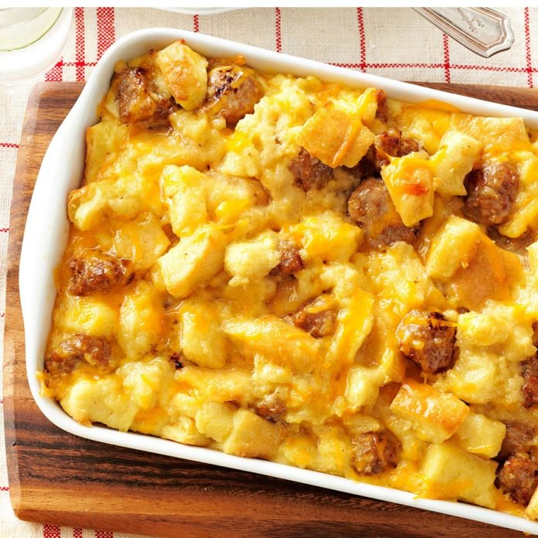

DIRECTIONS
- Preheat oven to 350 degrees. Spray a baking dish with non-stick spray.
- In a skillet, brown and crumble sausage; drain and set aside.
- In a large bowl, beat eggs; add milk, salt, pepper, mustard and any desired optional ingredients. Stir in bread cubes, cheese and sausage.
- Pour egg mixture into prepared baking dish.
- Cover and refrigerate for 8 hours or overnight. Remove from the refrigerator 30 minutes before baking. Bake, uncovered, at 350° for 40-50 minutes or until a knife inserted in center comes out clean. (Serve with a vegetable or fruit)

Prep Time: 15 minutes | Cook Time: 40-50 minutes | Total Time: 55-65 minutes | Yield: 30 servings

