Salsa Fresca Chicken
RECIPE
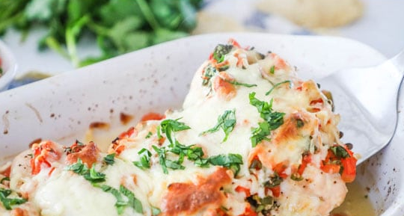
INGREDIENTS
- 24 (4oz) boneless skinless chicken breasts
- ¾ tsp cumin
- ¾ tsp salt
- ¾ tsp pepper
- ¾ tsp garlic powder
- 6 cups fresh Pico de Gallo
- 3 cup shredded mozzarella cheese
- Optional Ingredients:
fresh chopped parsley, cilantro, cheddar jack cheese,

DIRECTIONS
- Heat oven to 375 degrees. Spray baking pan with non-stick spray.
- Lay chicken flat in pan and sprinkle with cumin, garlic, salt and pepper.
- Spoon Pico de Gallo over chicken and top with cheese.
- Bake 25-35 minutes until chicken is cooked through reaching internal temperature of 165 degrees.
- Garnish with optional chopped parsley or cilantro.

Prep Time: 15 minutes | Cook Time: 25-35 minutes | Total Time: 40-50 minutes | Yield: 24 servings

