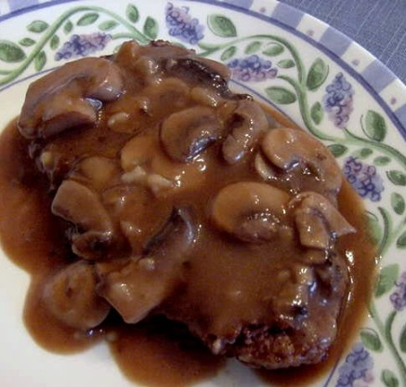
Salisbury Steak
RECIPE
INGREDIENTS
- 5 pounds ground beef
- 5 eggs
- 2 ¼ cups dry breadcrumbs
- 2 teaspoons garlic powder
- 2 tablespoons onion powder
- 3 tablespoons mustard powder
- 5 beef bouillon cubes crushed
- ½ cup + 1 teaspoon ketchup
- 5 tablespoons Worcestershire sauce
- Optional Ingredients:
onion minced for onion powder, green pepper minced,
parsley, beef base for beef bouillon, pepper

For Gravy
- 1 package of Roasted Brown Gravy Mix
- 1 gallon of water
- 1 can (#5) sliced mushrooms
- Optional Ingredients:
Cream of mushroom soup

DIRECTIONS
- Preheat oven to 375 degrees. Prepare a sheet pan with parchment paper or spray with non-stick spray.
- Bring water to a boil on stove top. Add gravy mix stirring continuously until gravy is thick. Stir in mushrooms and set aside.
- Place the ground beef into a large bowl and add eggs. Mix in bread crumbs, seasonings, bouillon, ketchup and Worcestershire sauce.
- Using a 4-ounce scoop, make 20 meat balls and shape them into oval patties flattening slightly.
- Fry patties in skillet browning meat on both sides. Meat will not be completely cooked. Transfer beef patties to a 2” pan and cover with prepared gravy.
- Bake in oven for 30-40 minutes or until internal meat temperature reaches 165 degrees.

Prep Time: 10 minutes | Cook Time: 45 minutes | Total Time: 55 minutes | Yield: 20 servings

