Rolled Spinach Pork Loin
RECIPE
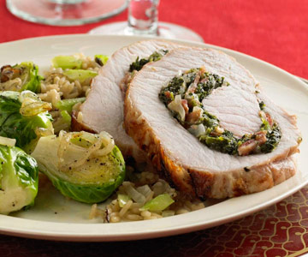
INGREDIENTS
- 2 tablespoons oil
- 2 medium onions, chopped small
- 4 cloves garlic, minced
- 2 (10 ounce) frozen chopped spinach, thawed and well-drained
- 16 slices bacon, crisp-cooked and crumbled
- 2 cup grated Parmesan cheese
- 7 pound boneless pork loin roast

Note: Try different stuffing (i.e. apples, cornbread, herb stuffing, mushroom). Be creative!

DIRECTIONS
- Preheat oven to 350 degrees. Spray 2” pan with non-stick spray.
- In a large skillet, heat oil over medium-hot heat. Add onion and garlic and cook until onion is tender but not brown. Remove skillet from heat. Stir in spinach, bacon and Parmesan cheese; set aside.
- Trim excess fat from pork. To pinwheel the pork loin, start cutting lengthwise 1/2 inch under the fat cap on the roast. As you cut the roast, gently rotate the roast at the same time. This will allow the roast to "unroll" as you cut it. When the roast is completely cut, it should be a rectangular piece of meat between 1/2 and 1-inch thick.
- Spread spinach mixture over cut side. Roll up the loin tightly from a long side to resemble the initial roast. Tie securely with 100 percent cotton kitchen string. Place the roast in prepared pan.
- Roast in oven for 90 to 105 minutes or until internal temperature is 145 degrees. Cover loosely with foil and let stand for 15 minutes before carving. Remove string; cut into slices.

Prep Time: 30 minutes | Cook Time: 90-105 minutes | Total Time: 120-135 minutes | Yield: 20 servings

