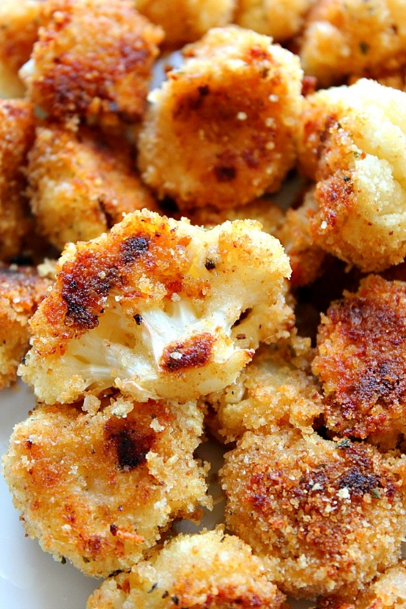
Roasted Garilc Parmesan Cauliflower
RECIPE

INGREDIENTS
- 2 cups butter, melted or olive oil
- 8 garlic cloves, minced
- 4 cups Italian or plain breadcrumbs
- 2 cups grated Parmesan cheese
- 1 teaspoon salt
- 1 teaspoon black pepper
- 4 cauliflower heads

Note: This recipe is best when used with fresh cauliflower.

DIRECTIONS
- Preheat oven to 375 degrees. Fan speed low. Line sheet pan with parchment paper. Set aside.
- Remove all leaves from cauliflower head. Cut cauliflower into florets, all roughly the same size. You can slice the large florets in half, if needed.
- Place breadcrumbs, salt, pepper and Parmesan cheese in a bowl and set aside.
- In another bowl place olive oil or melted butter, add minced garlic and stir. Drop in cauliflower pieces and coat with oil or butter.
- Place oiled or buttered cauliflower pieces in bowl with breadcrumb mixture and coat well.
- Place breaded cauliflower piece on prepared sheet pan. Repeat until you use up all cauliflower.
- Roast cauliflower for 22-28 minutes, or until the breading is golden brown.

Prep Time: 15 minutes | Cook Time: 22-28 minutes | Total Time: 37-43 minutes | Yield: 24 servings

