Roasted Chicken
RECIPE
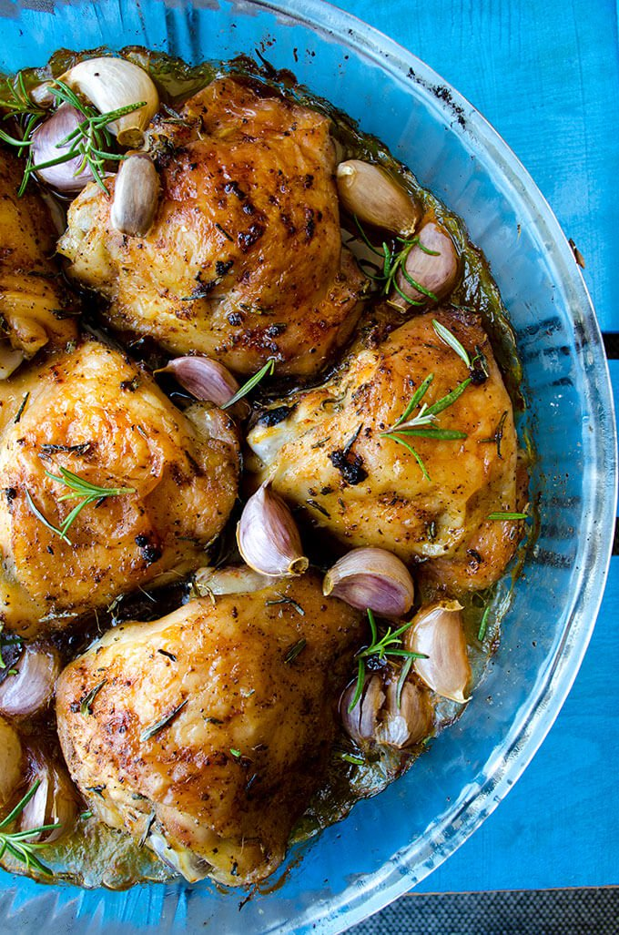
INGREDIENTS
- 24 chicken thighs (may use chicken pieces, they will need to cook longer)
- 1/3 cup oil
- Salt and pepper
- Optional Ingredients
Parsley, dill, basil, sage, poultry seasoning, rosemary, garlic powder, onion powder, garlic cloves, thyme,
paprika

DIRECTIONS
- Preheat oven to 375 degrees. Line a large baking sheet with parchment paper and set aside.
- Pat the chicken dry with paper towels and place on the baking sheet.
- Drizzle oil evenly over both sides of the chicken, rubbing to coat well.
- Season with salt and pepper.
- Bake in preheated oven for 20 minutes. Reduce heat to 325F and bake for 30-40 minutes or until internal temperature reaches 165 degrees.

Prep Time: 5 minutes | Cook Time: 40-50 minutes | Total Time: 45-55 minutes | Yield: 24 servings

