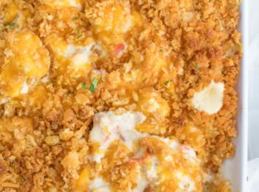
Ritzy Chicken
RECIPE
INGREDIENTS
- 24 (4 ounce) boneless, skinless chicken breasts
- 1 ½ sticks butter
- 1½ onion, chopped
- 6 garlic cloves, minced
- 1½ teaspoon black pepper
- 3 (10.75 oz) cans cream of chicken soup
- 3 cups sour cream
- 1½ cups milk
- 84 butter (ritz-type) crackers, crumbled
- 3 cup cheddar cheese
- Optional Ingredients:
bell peppers, green onions

DIRECTIONS
- Preheat oven to 325 degrees. Spray a baking pan with non-stick spray.
- Heat skillet, spray with non-stick spray and brown chicken 4-5 minutes on each side before removing the chicken to a plate and chopping roughly.
- Melt ½ stick (4 tablespoons) butter in skillet, add onions, garlic and black pepper on medium heat and cook for 4-5 minutes until the onions are translucent.
- Add in the cream of chicken, sour cream and milk and mix well then pour the mixture into prepared pan.
- Melt the remaining butter and mix with crumbled crackers and cheddar cheese. Sprinkle over the chicken then bake for 30-35 minutes.

Prep Time: 20 minutes | Cook Time: 60-65 minutes | Total Time: 80-85 minutes | Yield: 24 servings

