Refried Beans
RECIPE
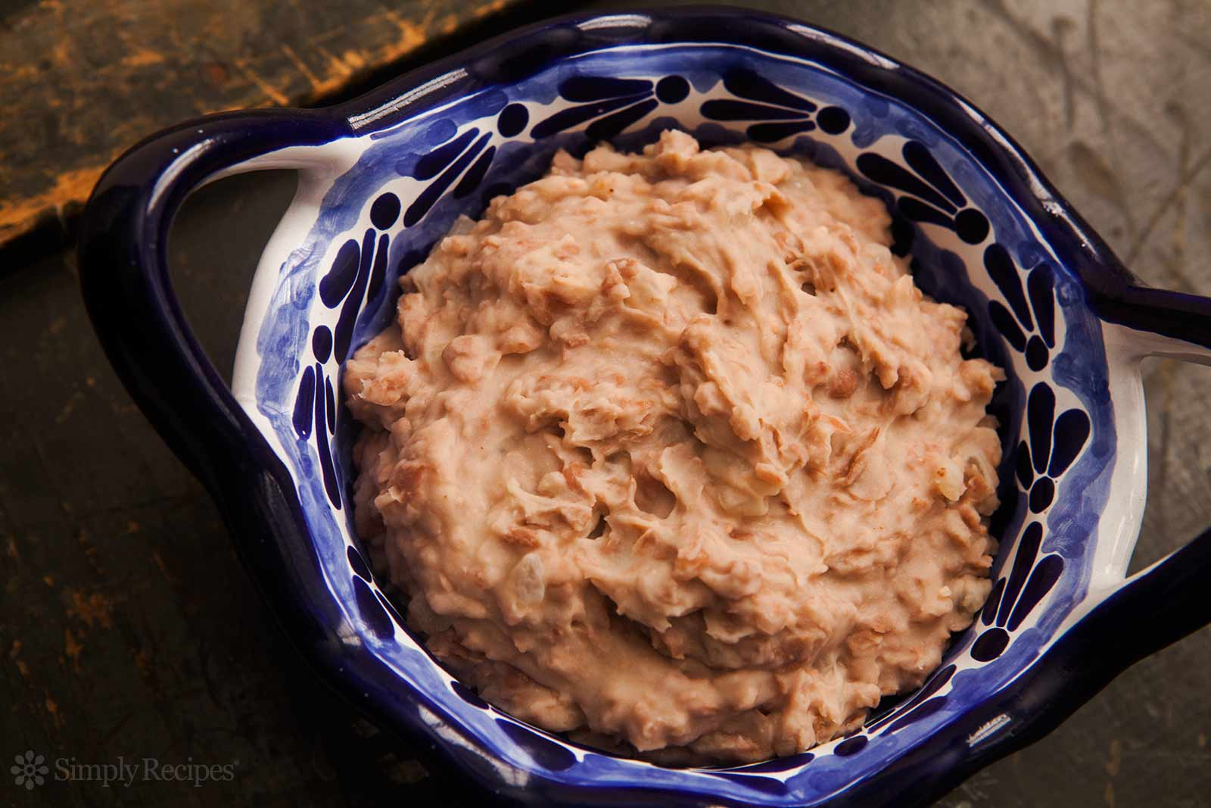
INGREDIENTS
- 3 pounds dried pinto beans
- 8-10 garlic cloves, minced
- Water
- Salt to taste (approx. 4-5 teaspoons)
- Optional Ingredients:
Canned pinto beans, pepper, chicken broth, chili powder, onion, milk

DIRECTIONS
- Sort through the beans to ensure that they are good. Rinse with water in a colander to clean. May soak beans for a period of time, if desired.
- Add beans and minced garlic to a large pot. Pour water in. Beans should be fully submerged in water.
- Bring to a boil, then turn the heat to low and continue to simmer covered. Allow to cook for about 1 and 1/2 hours, stirring every half hour, until beans are soft. If beans are not soft as desired, add additional water and cook longer.
- Once the beans are soft, remove the lid and continue to cook uncovered until all water is absorbed. Mash the beans to desired consistency and add salt. If you want the beans to be creamier, add milk and stir to combine. Serve warm.

Prep Time: 10 minutes | Cook Time: 90 minutes | Total Time: 100 minutes | Yield: 24 servings

