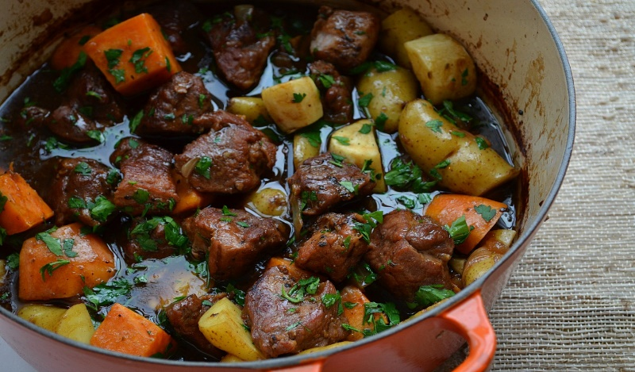
Pork Stew
RECIPE

INGREDIENTS
- 5 pounds pork cubes
- 1 ½ cups all-purpose flour
- 2 tablespoons seasoned salt
- 2 teaspoons black pepper
- ¾ cup vegetable oil
- 2 large yellow onions, diced
- 1 tablespoon minced garlic
- 7 ½ cups water
- 3 tablespoons of beef base paste
- 1 tablespoon thyme
- 10 potatoes peeled and diced into chunks
- 2 cups carrots, sliced
- Optional Ingredients:
peas, corn, celery, Worcestershire sauce, beef stock, tomato paste, bay leaves

DIRECTIONS
- Preheat oven to 325 degrees. Spray a 2” pan with non-stick spray.
- In a plastic bag, add flour, pepper and seasoned salt. Close bag and shake to combine ingredients. Add meat to flour a handful at a time and coat with flour mixture.
- In large pot, over medium high heat, pour 1/3 of your vegetable oil. Oil should be hot so that the meat will brown quickly.
- Add floured pork chunks to oil for browning. Once browned, remove from pan and repeat with remaining pork until all meat is browned. Do not cook pork all the way. Set browned meat aside.
- If necessary, add a tad bit more oil to bottom of pan and turn heat down to medium, then add onions and garlic. Cook until translucent. Scrape bottom of pan to loosen any brown bits (lots of flavor in the bottom of the pot).
- Mix water and beef base paste to make a stock; stir till dissolved. Add beef stock, browned pork and thyme to pot.
- Transfer to prepared serving pan. Cover with foil and bake for 1 ¼ hours.
- Add carrots and potatoes and bake for 1 hour or until meat and vegetables are tender.

Prep Time: 80 minutes | Cook Time: 75 minutes | Total Time: 155 minutes | Yield: 24 servings

