Pork Shoulder with AppleKraut
RECIPE
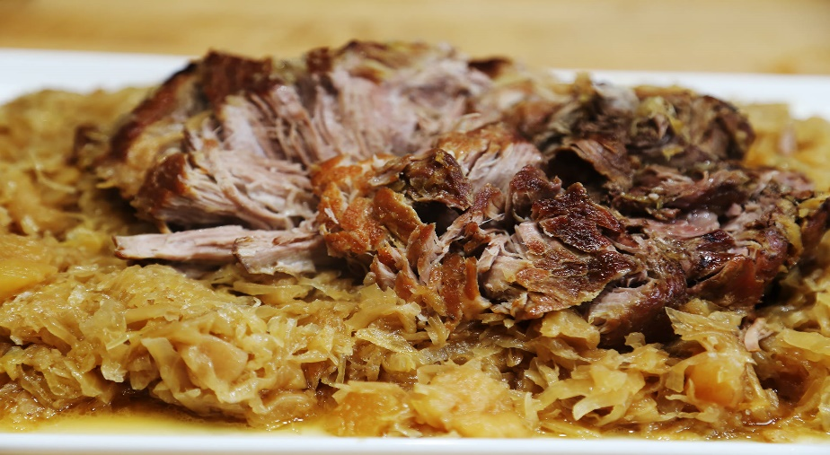
Note: Pork shoulders or butts can often be obtained through OFH at very little cost.
INGREDIENTS
- 3 pork shoulder roasts (approx. 5 pounds)
- Salt and pepper
- 6 tablespoons butter
- 6 tablespoons oil
- 3 onions, thinly sliced
- 9 apples, peeled, cored, quartered
- 1 tablespoon thyme
- 1½ cups chicken stock
- 1 (#10) can sauerkraut, squeezed dry
- ¾ cup packed brown sugar
- 3 tablespoons caraway seeds
- Optional Ingredients:
apple cider vinegar, garlic powder, paprika

DIRECTIONS
- Preheat oven to 325 degrees. Fan speed high. Prepare deep pan with non-stick spray.
- Season pork with salt and pepper. In a skillet over medium-high heat, melt butter with oil. Add pork, turning frequently, until browned on all sides, about 10 minutes. Set aside.
- Add the onion, apples and thyme. Sauté until onion and apples are lightly browned, about 5 minutes. Set aside.
- Pour off fat from skillet. Add chicken stock to deglaze, stirring to scrape up the browned bits from the bottom.
- Cover bottom of prepared pan with sauerkraut. Sprinkle with brown sugar and caraway seeds. Place pork on top and surround with apple mixture. Pour on deglazing mixture. Cover and bake until pork is fork-tender approximately 4 hours.

Prep Time: 30 minutes | Cook Time: 4 hours | Total Time: 270 minutes | Yield: 24 servings

Oven-Roasted Pork Roast for Sliced Pork
RECIPE
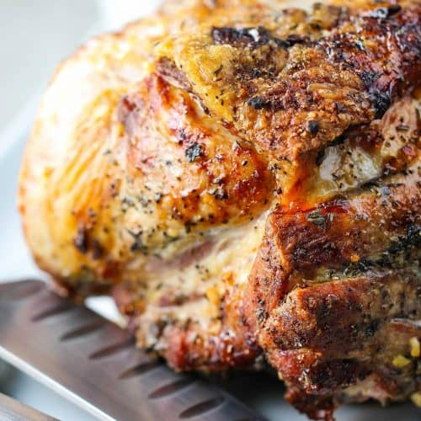
INGREDIENTS
- 2 (10 pound) pork shoulders/butts
- 4 tablespoons salt
- 2 tablespoons black pepper
- 2 tablespoons cumin
- 2 tablespoons onion powder
- 4 tablespoons garlic powder
- 2 tablespoons oregano

Note: Pork shoulders or butts can often be obtained through OFH at very little cost.

DIRECTIONS
- Preheat oven to 400 degrees. Fan speed high. Prepare deep pan with non-stick spray.
- Combine spices in a small bowl. Rinse pork shoulders under cold water.
- Rub spice mixture all over the surface of the meat. Place meat in prepared pan. Add 2-3 cups of water.
- Roast uncovered for 30 minutes to brown. Reduce heat to 325 degrees and roast for approximately 2-3 hours or until meat is tender, adding more water to the pan as needed.
- Remove roast from oven and let rest for 15-30 minutes before slicing.

Prep Time: 10 minutes | Cook Time: 2-3 hours | Total Time: 160-190 minutes | Yield: 28-30 servings

