Pork Carnits Taco
RECIPE
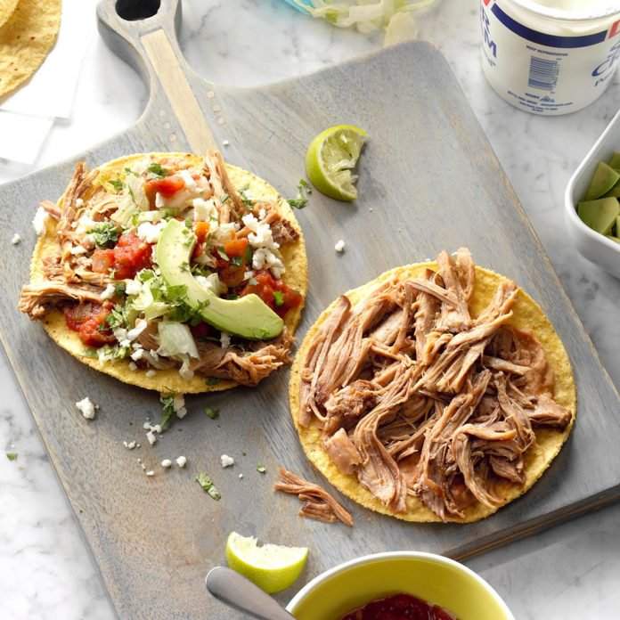
INGREDIENTS
- 5 pounds’ pork Carnitas
- 20-25 flour tortillas
- Toppings can include the following choices: avocado in various forms, diced onion, shredded cheese, sour cream, diced tomatoes, Pico de Gallo, diced green onions and so forth. Put these toppings on at time of service or for ease of service, put on salad bar and let guests put on what they would like.

DIRECTIONS
- Preheat oven to 350 degrees.
- Wrap a stack of five tortillas in a packet of aluminum foil and put it in a pre-heated oven for 15-20 minutes, until heated through.
- Heat pork Carnita meat with liquid to 140 degrees. Spoon Carnita meat to onto warm tortilla.
- Add your favorite topping and serve immediately.

Prep Time: 20 minutes | Cook Time: 30 minutes | Total Time: 50 minutes | Yield: 20-25 servings

