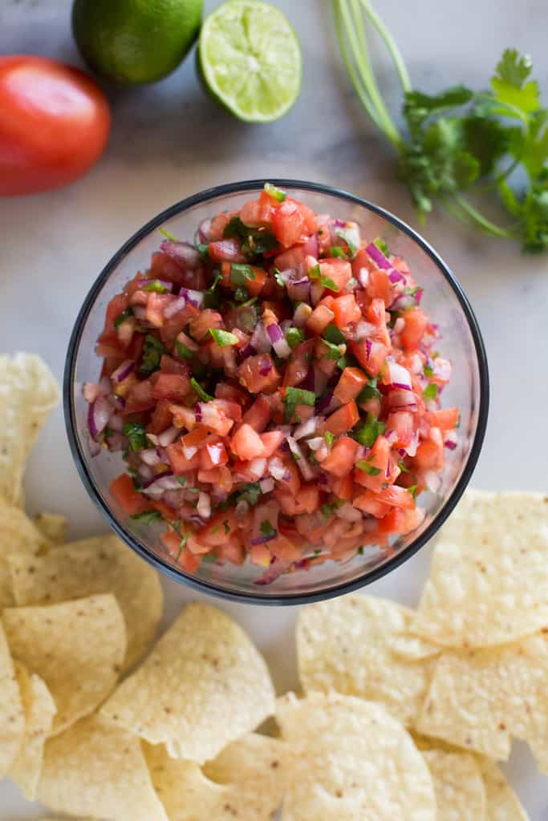
Pico De Gallo
RECIPE

INGREDIENTS
- 10 tomatoes
- 2 cups onion
- 2 cups fresh cilantro
- 4 small jalapenso
- 2-3 tablespoons lime juice
- Salt
- Optional Ingredients:
cumin

DIRECTIONS
- Combine tomatoes, onion, cilantro and jalapeño in a bowl.
- Season with salt and add lime juice to taste.

Prep Time: 5 minutes | Cook Time: 10 minutes | Total Time: 15 minutes | Yield: 24 servings

