Philly Steak Sandwich
RECIPE
INGREDIENTS
- 5 pounds thinly sliced fully cooked pot roast
- 2 thinly sliced red onions
- 2 thinly sliced green peppers
- ½ pound thinly sliced mushrooms
- 10 slices of American cheese
- 10 Slices of American Swiss cheese
- 20 hoagie buns
- Optional Ingredients:
mushrooms

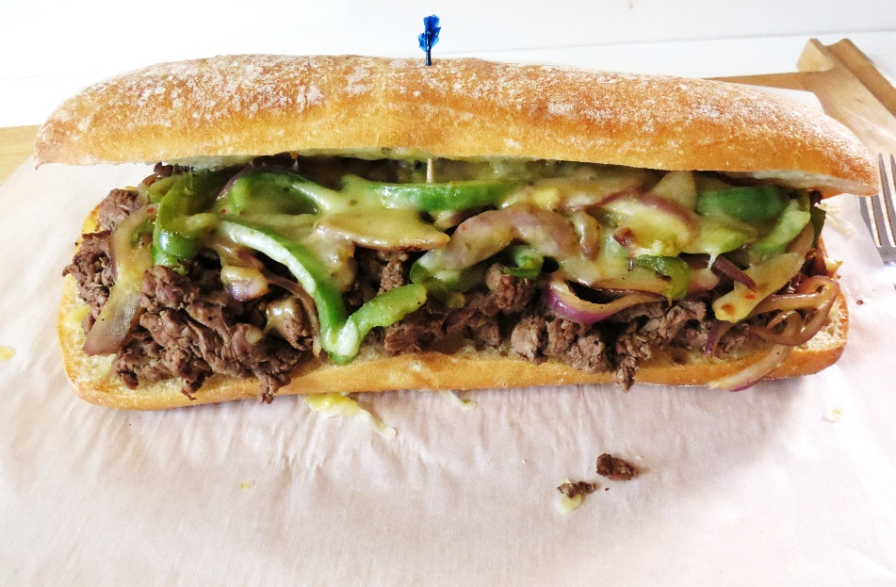

- Thinly slice roast and slowly heat on stove top or in oven and bring to 140 degrees
- Sautee onions and peppers until onions caramelize.
- While veggies are cooking, slice open hoagie rolls and lay on sheet with cut side up. Brush buns with butter
- Toast Hoagie rolls in oven or grill top if you have one.
- Add 3-4 ounces of beef to toasted hoagie. Add sautéed vegetables and mushrooms, and one each of the cheeses (slice Swiss and American in half then add American then top with Swiss)
- Put sandwiches back in the oven and melt cheese

Prep Time: 30 minutes | Cook Time: 120 minutes | Total Time: 150 minutes | Yield: 24 servings

