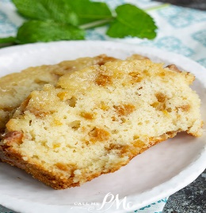 Peach Bread Loaf

Ingredients
1 bag white or yellow cake mix, (make mix according to directions on bag)

#10 can peaches drained (reserve juice for glaze)

For Peach Powdered Sugar Glaze:

Reserved Peach juice (USE ENOUGH TO MAKE POWDER SUGAR THE CONSISTANCY YOU LIKE)

1 bag powdered sugar

Instructions: Preheat the oven to 350°F. Grease loaf pan. Pour batter into the prepared loaf pan. Place in the preheated oven. Bake for 45 to 50 minutes. The bread will be done when a toothpick inserted in the center comes out clean or with dry crumbs. Cool cake completely and top with powdered sugar glaze that you used the reserved peach juice to make as thick or thin as you like.

