Patty Melt
RECIPE
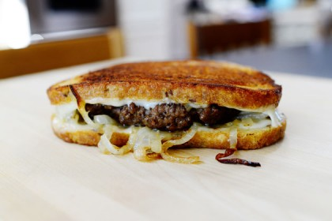
INGREDIENTS
- 2 sticks butter
- 5-6 yellow onions sliced
- 5 pounds ground beef
- 5 tablespoons Worcestershire sauce
- Salt and pepper
- 40 slices Swiss cheese
- 40 slices bread any variety

DIRECTIONS
- In a medium skillet, melt 1 stick of butter over medium-low heat. Add sliced onions and cook slowly for 20 to 25 minutes, stirring occasionally, until the onions are golden brown and soft.
- In a medium bowl, mix together the ground beef, salt & pepper, and Worcestershire to combine.
- Using a 4-ounce scoop, make 20 balls. Form into patties and press with your finger to make a dent in the middle of the burger (stops burger from become dome shape and shrinking when cooking).
- In a skillet over medium heat, cook patties on both sides until totally done so that internal temperature reaches 165 degrees.
- To assemble, place one slice of cheese on bread, then patty and some cooked onions, another slice of cheese, and final slice of bread. On a clean griddle or in a skillet, melt some butter and grill the sandwiches over medium heat until golden brown on both sides and cheese is melted. May need to add additional butter when flipping to brown.
- Slice in half and serve immediately!

Prep Time: 15 minutes | Cook Time: 20 minutes | Total Time: 30 minutes | Yield: 20 servings

