Parmesan Crusted Baked Fish
RECIPE
INGREDIENTS
- 20 fish fillets, 4 oz each
- Salt & pepper
- Non-stick spray

For Coating
- 3 ¾ cup grated Parmesan cheese
- 3 ¾ cup panko breadcrumbs
- 2 tablespoons dried parsley
- 2 tablespoons garlic powder
- 2 tablespoons onion powder
- 1 teaspoon ground mustard
- 2 tablespoons chives
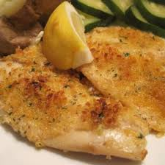

DIRECTIONS
- Preheat oven to 425°F. Spray sheet pan with non-stick spray.
- Pat fish dry with paper towels removing the moisture ensures they won't get mushy while baking.
- Season fish with salt and pepper.
- In a bowl, mix together cheese, breadcrumbs, parsley, garlic powder, onion powder, ground mustard, and chives. Coat each fillet in breadcrumb mixture and place on prepared pan. Then spray top of each fillet with non-stick spray.
- Bake 10-12 minutes or until fish is flaky and cooked.

Prep Time: 20 minutes | Cook Time: 10-12 minutes | Total Time: 30-32 minutes | Yield: 20 servings

