Pancakes
RECIPE
INGREDIENTS
- 7 ½ cups all-purpose flour
- 2/3 cup sugar
- 3 tablespoons + 1 teaspoon baking powder
- 5 teaspoon baking soda
- 2 ½ teaspoon salt
- 5 cup milk
- 10 large eggs
- 1 ¼ cup melted butter
- Optional Ingredients:
buttermilk, vanilla, bananas, chocolate chips, nuts, peanut butter, pumpkin, cinnamon, apples

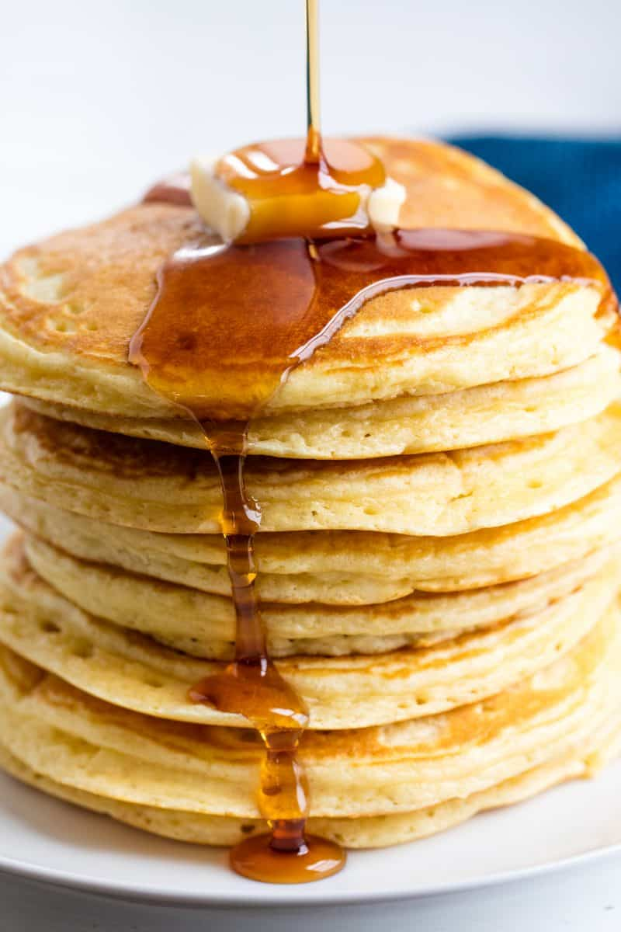

DIRECTIONS
- In a large mixing bowl, sift together flour, sugar baking powder, baking soda, salt and any desired optional ingredients.
- Whisk in milk, eggs, and melted butter just until combined.
- Preheat a flat griddle over medium-high heat.
- Scoop ¼ cup of pancake batter onto griddle. Let pancakes cook until bubbles form before flipping.
- Cook other side until golden brown. Serve hot with syrup.

Prep Time: 20 minutes | Cook Time: 45 minutes | Total Time: 65 minutes | Yield: 20 servings

