Oven-Roasted Pork Roast for Pulled Pork
RECIPE
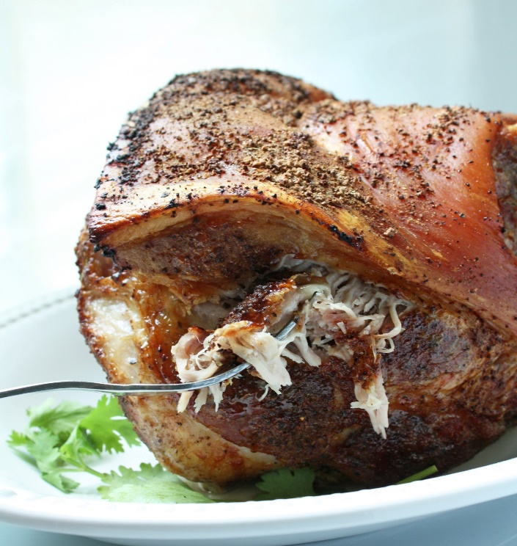
INGREDIENTS
- 2 (10 pound) pork shoulders/butts
- 4 tablespoons salt
- 2 tablespoons black pepper
- 2 tablespoons cumin
- 2 tablespoons onion powder
- 4 tablespoons garlic powder
- 2 tablespoons oregano

Note: Pork shoulders or butts can often be obtained through OFH at very little cost.

DIRECTIONS
- Preheat oven to 300 degrees. Fan speed high. Prepare deep pan with non-stick spray.
- Combine spices in a small bowl. Rinse pork shoulders under cold water.
- Rub spice mixture all over the surface of the meat. Place meat in prepared pan. Add 2-3 cups of water.
- Roast covered for approximately 4 hours until meat is tender.
- Remove roast from oven and let rest for 15-30 minutes. Pull meat apart. Adjust seasonings if necessary.

Prep Time: 10 minutes | Cook Time: 4 hours | Total Time: 250 minutes | Yield: 28-30 servings

Oven-Roasted Pork Roast for Sliced Pork
RECIPE
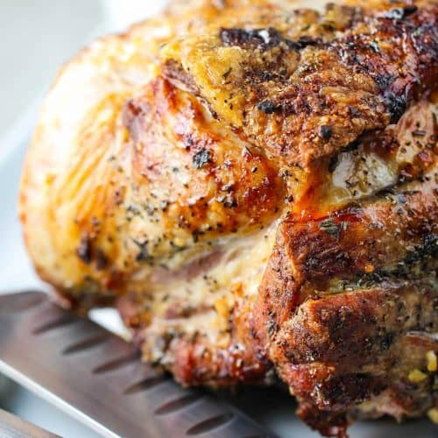
INGREDIENTS
- 2 (10 pound) pork shoulders/butts
- 4 tablespoons salt
- 2 tablespoons black pepper
- 2 tablespoons cumin
- 2 tablespoons onion powder
- 4 tablespoons garlic powder
- 2 tablespoons oregano

Note: Pork shoulders or butts can often be obtained through OFH at very little cost.

DIRECTIONS
- Preheat oven to 400 degrees. Fan speed high. Prepare deep pan with non-stick spray.
- Combine spices in a small bowl. Rinse pork shoulders under cold water.
- Rub spice mixture all over the surface of the meat. Place meat in prepared pan. Add 2-3 cups of water.
- Roast uncovered for 30 minutes to brown. Reduce heat to 325 degrees and roast for approximately 2-3 hours or until meat is tender, adding more water to the pan as needed.
- Remove roast from oven and let rest for 15-30 minutes before slicing.

Prep Time: 10 minutes | Cook Time: 2-3 hours | Total Time: 160-190 minutes | Yield: 28-30 servings

