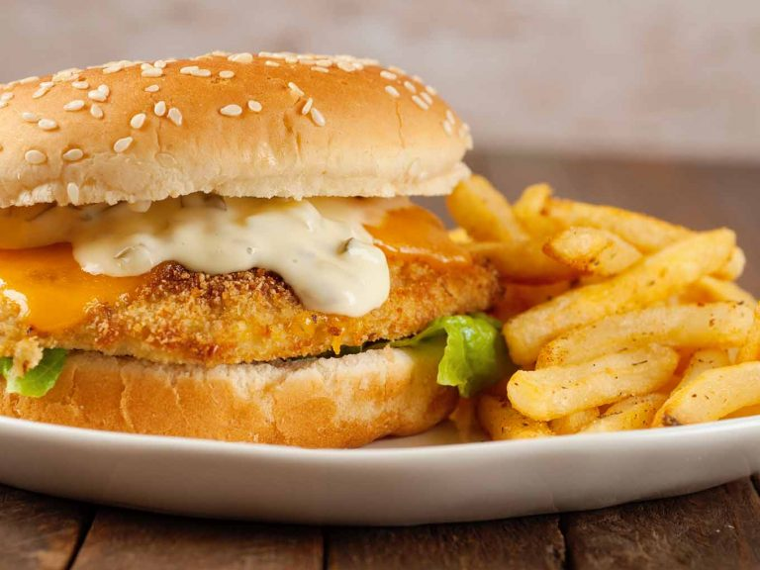
Oven-Fried Fish
RECIPE
Sandwich

INGREDIENTS
- 20 Swai fillets, 3-5 oz. each
- 5 large eggs
- 1/3 cup milk
- 6 cups dry seasoned breadcrumbs
- Salt and pepper
- Non-stick spray
- Leaf lettuce
- 20 slices American cheese
- 20 soft sandwich rolls

For Tartar Sauce
- 1 cup mayonnaise
- 2 tablespoons sweet pickle relish (well drained)
- 1 teaspoon paprika
- 4 teaspoons lemon juice
- 3 tablespoons sweet onion, very finely chopped

DIRECTIONS
- Preheat oven to 425°F. Line a sheet pan with parchment and spray with nonstick spray.
- Prepare tartar sauce by combining the mayonnaise, relish, paprika, lemon juice and onion in a small mixing bowl. Refrigerate until ready to use.
- Whisk egg and milk together in a shallow dish. In a shallow dish, combine breadcrumbs, 2 tablespoons of salt and 1 teaspoon of black pepper.
- Dip both sides of fish in egg mixture. Press fillets gently into breadcrumbs to coat well. Arrange fish fillets on the prepared baking sheet and drizzle evenly with a little vegetable oil.
- Bake until fish flakes easily and the coating is crisp and golden, 10 to 12 minutes. Top each piece of fish with a slice of cheese and return them to the oven until the cheese melts, 2 to 3 minutes.
- To serve, place some lettuce on the bottom half of each roll and top with a piece of fish and a spoonful of tartar sauce.

Prep Time: 20 minutes | Cook Time: 15 minutes | Total Time: 35 minutes | Yield: 20 servings

